Development of a 2-D Quantitative LIF Technique for Measurement of Transient Liquid Fuel Films Utilising Total Internal Reflection

Alonso, M.^{1,*}, Bowen, P.J.¹, Kay, P.J.¹, Gilchrist, R.², Sapsford, S.², Owen, N. ²
¹Cardiff School of Engineering, The Parade, Cardiff CF24 3AA, UK
2 Ricardo UK, Shoreham-by-sea, West Sussex BN43 5FG, UK
* E-mail : AlonsoM@Cardiff.ac.uk
*Tel: +44(0)2920 875010, Fax: +44 (0)2920 874939

Abstract: This paper describes the development of a 2D Laser Induced Fluorescence (LIF) technique to quantify the thickness of transient liquid fuel films formed as a result of spray impingement. The LIF technique relies on the principle that upon excitation by laser light the intensity of the fluorescent signal from a dopant (10 % by-vol of 3-pentanone in iso-octane) is proportional to the film thickness. A Nd:YAG laser was used as the excitation light source (utilising the fourth harmonic at wavelength 266 nm) and an intensified CCD camera recorded the results as fluorescent images. The propagation of the exciting laser beam through the optical piston was carefully controlled by total internal reflection so that only the fuel film was excited and not the airborne droplets above the film. Some preliminary experimental results of a transient spray from a gasoline direct injector impinging on to a quartz crown are presented, with observations of the transient nature of the fuel film discussed. The results are also discussed in light of popular post-impingement models found in the literature.
Introduction
Spray/wall interaction upon solid surfaces is an unavoidable phenomenon that occurs in direct injection internal combustion engines, influencing greatly the air-fuel mixing and combustion. Fuel impingement is generally undesirable because its association with UBHC emissions and fuel economy. For instance, for gasoline DI engines working at part load literature has shown that if 10 % of the mass injected impinges on the piston crown there is a 60-90 % associated increase in UBHC emissions compared to complete vaporisation, and a 30 % associated increase at idle load [1,2]. For that reason it is of great importance to improve the understanding of this event.
This article describes the development of a temporally-resolved 2-D laser induced fluorescence technique (LIF) to analyse and quantify the transient fuel film formed due to impingement of a pressure swirl gasoline direct injection (G-DI) spray on a quartz flat surface. The technique complements time resolved post-impingement spray characterisation by Kay et al [3,4].
It follows work by Kay et al [4], who developed a 2-D LIF technique to quantify the fuel film thickness formed as a result of impingement. That technique relies on the principle that upon excitation by laser light, the intensity of the fluorescent signal from a dopant is proportional to the film thickness.
The technique, as well as the work presented in this article, uses a binary mixture of 10 % by-vol of 3-pentanone in iso-octane, where iso-octane non fluorescent base represents gasoline, and 3-pentanone acts as a fluorescent dopant. This mixture is frequently used as a gasoline substitute for LIF studies in IC engines research due to its similar properties [5]. Also, it provides a solution to the variance in concentration of gasoline from different batches, creating difficulty repeating and calibrating experiments [6].
Nd:YAG LASER
4th Harmonic
(266 nm)
Intensified CCD Camera
Mirror
Dichroic Filter
Injector
Fuel Film
Quartz Piston
Figure 1: Optical Setup proposed by Kay [4].
The optical setup previously proposed is presented in Figure 1. Initial tests at atmospheric conditions showed that airborne droplets affect the fluorescent signal from the fuel film, due to the fact that the laser continues its path upwards and the light excites the airborne liquid fuel above the piston surface, increasing the fluorescence signal detected by the camera.
However, a single injection on the quartz piston demonstrated the potential of the technique, as the intensity of the fluorescence decreased as the fuel evaporated. Therefore, the limitation of this technique was present only analysing transient fuel films for multiple injections, where there is airborne fuel above the film. Another limitation of this technique concerns the strong presence of the laser beam pattern in the images, producing bright and dark areas for points with the same thickness introducing errors to the system. These issues contributed to problems experienced in achieving plausible quantitative data in that study.
This paper proposes a different optical setup in which the propagation of the laser sheet is carefully controlled so that only the fuel film is illuminated. Additionally, improvement was made correcting the distribution of the laser beam pattern, and creating a more homogeneous beam distribution.

total internal reflection
To avoid a fluorescence signal form airborne droplets, the propagation of the exciting laser beam must be limited in a way that only excitation of the fuel film takes place. This work proposes using the principle of total internal reflection to eliminate or reduce this source of error. When light strikes a medium with lower refractive index, n, from a medium with higher refractive index, n', (interface quartz-air), it will be totally reflected if the incident angle is larger than the critical angle determined by the Snell law (Equation 1).
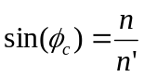
(1)

Previous work by Kull [7] and Hoon [8], used the LIF technique to visualize fuel films on quartz surfaces, and showed that even if the incident angle of the light is such that it produces total internal reflection, part of the light can propagate from the quartz into the fuel due to the similarity in the refractive indices. This is due to the fact that the path of light hardly changes when it propagates into mediums with similar refractive indices.

Hoon [8] showed that after passing the fuel layer and exciting the fuel film, the light interacts with the fuel-air interface, and is totally reflected if the curvature of the fuel film surface is small because of the large difference in the refractive index. Thus the light only excites the fuel on the piston and there is no fluorescence contribution from airborne droplets.

Nd:YAG LASER
4th Harmonic
(266 nm)

Intensified CCD Camera
Mirror
Injector
Fuel Film
Quartz Piston
Beam Dump
Energy Pulse Monitor (EPM)
UV Diffuser
Beam Expander
Fluorescence Signal
Figure 2: Optical Setup to control the light propagation by total internal reflection.
Dichroic Filter
Optical Setup
Figure 2 shows the optical setup proposed for this technique based on the principle of total internal reflection. In order to implement this technique it is necessary to design a quartz piston in which the exciting laser beam could be directed towards the top surface at a desired angle, in this case an angle greater than the critical angle to ensure total internal reflection.

A Nd:Yag laser utilising the fourth harmonic (266 nm) is used as the excitation light source, and an intensified CCD camera is used to capture the fluorescence signal emitted by the fuel film. It is possible to capture only the fluorescence from the excited fuel using a 400 nm short band pass camera filter, since it is well documented that the fluorescence of 3-pentanone excited at 266 nm peaks at around 400 nm. In addition, specially coated mirrors were used to maximise the transmittance of both laser 266 nm UV, and 400 nm fluorescence signals. Also, by means of an energy pulse monitor (EPM) it is possible to monitor and record laser power fluctuations (shot-to-shot variation), so that this parameter can be taken into consideration in the calibration.

A 5º full width half maximum (FWHM) UV diffuser optic is used to attenuate the typically uneven power distribution of the Nd:Yag laser beam pattern, aiming to make the beam profile more homogeneous (‘top-hat shape’). Without an UV-diffuser, there would be relative hot spots and dark areas in the laser beam, introducing sources of error.
Calibration Procedure

It is well documented that the intensity of fluorescence emitted by 3-pentanone excited at 266 nm is linearly proportional to its concentration [4], and thus proportional to the thickness, for ‘thin’ film layers of homogeneous mixtures. In order to calibrate this

technique it is essential to determine a ratio between the fluorescence signal recorded and the liquid film thickness corresponding to that signal.

The calibration method is based on the principle that knowing the volume, footprint area, and intensity distribution from a fuel film it is possible to determine a calibration curve for which specific values of intensity can be assigned to corresponding values of thickness. A micropipette is used for the calibration of this technique to deposit a known volume of fuel on the quartz surface. In this case, the fluorescence from a 10 mm³ drop was recorded giving information of intensity distribution and droplet area. Figure 3b shows a typical image used for the calibration of this technique after subtracting the background and some noise. The criteria for subtracting the present noise will be explained in the next section.

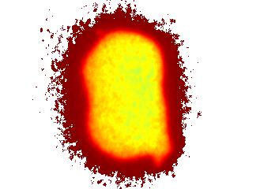 | 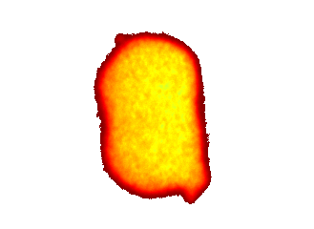
(a) | (b)
Figure 3: Intensity recorded from a 10 mm³ fuel drop after background subtraction. a) Without noise subtracted, b) with noise subtracted.

From the information provided from a calibration image like figure 3b, can be approximated the volume of the fuel film as the sum of the product of the thickness and area of each pixel (Equation 2).

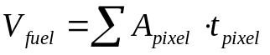
(2)

Additionally, since the intensity of the fluorescence signal is linearly proportional to the thickness, assuming that the calibration curve passes though zero, one can also approximate the fuel thickness using Equation 3, where k is the proportionality constant, I is the intensity and t the thickness of the corresponding pixel.
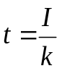

(3)

Since the volume of fuel is known, it is possible to calculate the calibration constant from Equation 4.
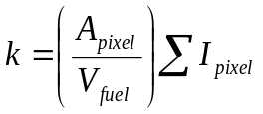

(4)

Additionally, using the energy pulse monitor, the output power of the laser was recorded for each calibration image. As a result, a linear calibration relating the fluorescence intensity to the laser output for the corresponding pulse was derived.
Due to the sensitivity of the technique to changes in the optical setup and batch concentration, the technique needs to be calibrated on a daily basis and for each new batch of fuel.
Post-Processing
The fuel thickness images were obtained after subtracting a background image to ensure that the resulting image contains only the fluorescent signal emitted by the excited fuel. Even after subtracting the background, the presence of residual ‘noise’ is clear in the images as presented in Figure 3a. For that reason, a further calibration image is subtracted from the recorded image after background noise subtraction. This systematic ‘error’ image comprises several potential sources, and is referenced in previous quantitative LIF studies [9]. Here, the calibration image is derived from the droplet image shown in Figure 3 by identification of the steep intensity gradient associated with the droplet boundary. The same error image used to obtain the final image in Figure 3b is then used as part of the calibration procedure in quantifying the LIF image for the transient sprays. Further error analysis is ongoing to better understand the sources of signal which together comprise the calibration image. This calibration procedure had only a small influence on the fuel film thickness, but due to the accumulative effect, had a more significant impact on the total mass deposited (circa 20%).
Results
Transient fuel thickness measurements are presented in this section for selected timebins to portray the development of the liquid film formed as a result of impingement for a BOSCH C2-70 pressure swirl injector located at 21 mm and 45º with respect to the normal of the impact surface. The injection duration of the test was 1.5ms.
 | 
(ai) | (aii)
 | 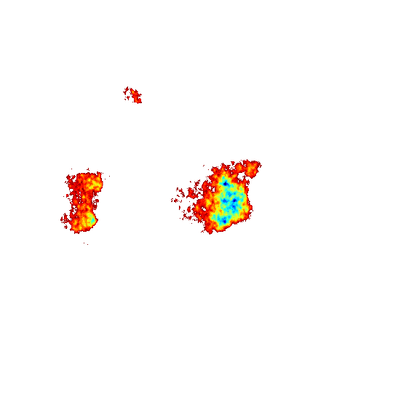
(bi) | (bii)
Figure 4: Transient fuel thickness measurements for different timebins: (a) 1.00 ms ASOI, (b) 1.25 ms ASOI (left: side view, right: Footprint image with background and noise subtracted)

Side View | Footprint Image with Background and Noise Subtracted | Processed Image
 | 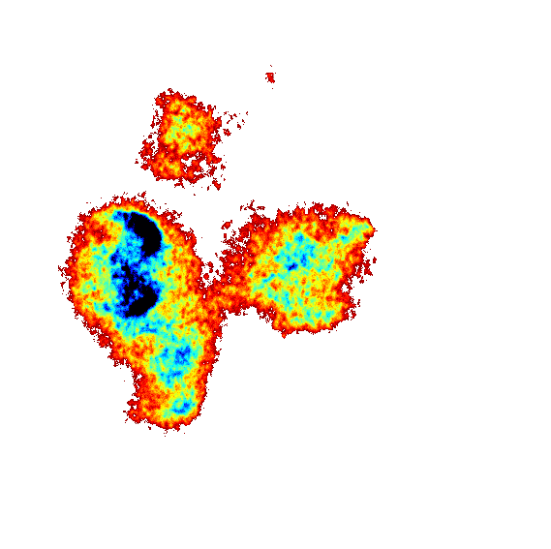 | 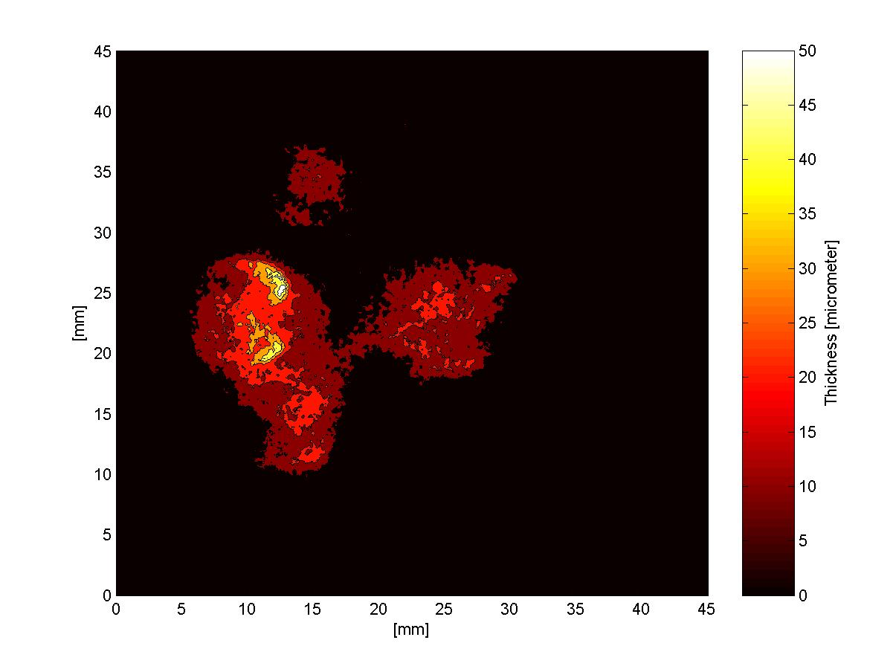
(ai) | (aii) | (aiii)
 | 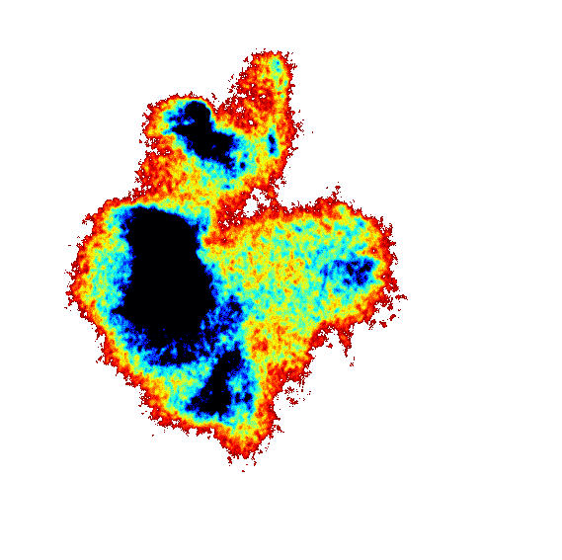 | 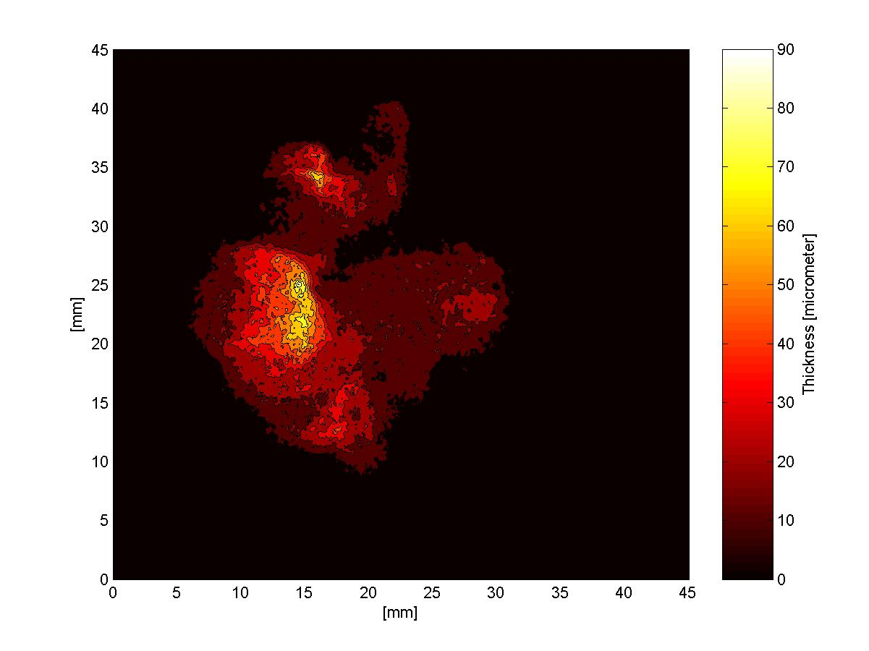
(bi) | (bii) | (biii)
 | 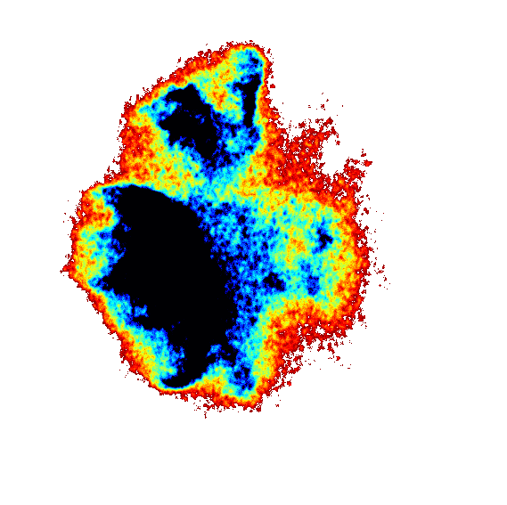 | 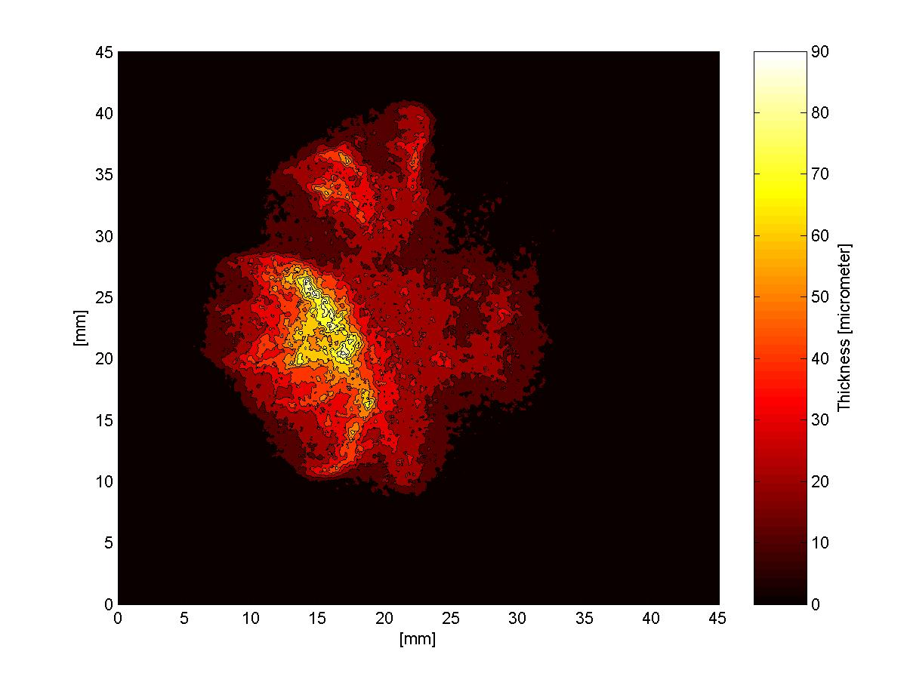
(ci) | (cii) | (ciii)
 | 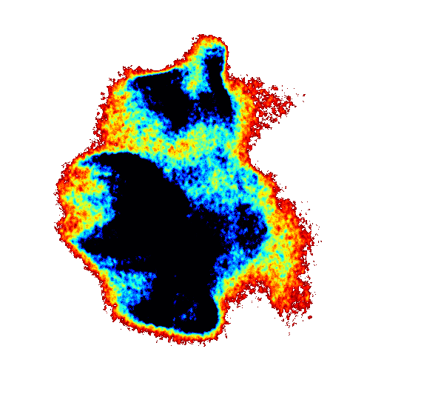 | 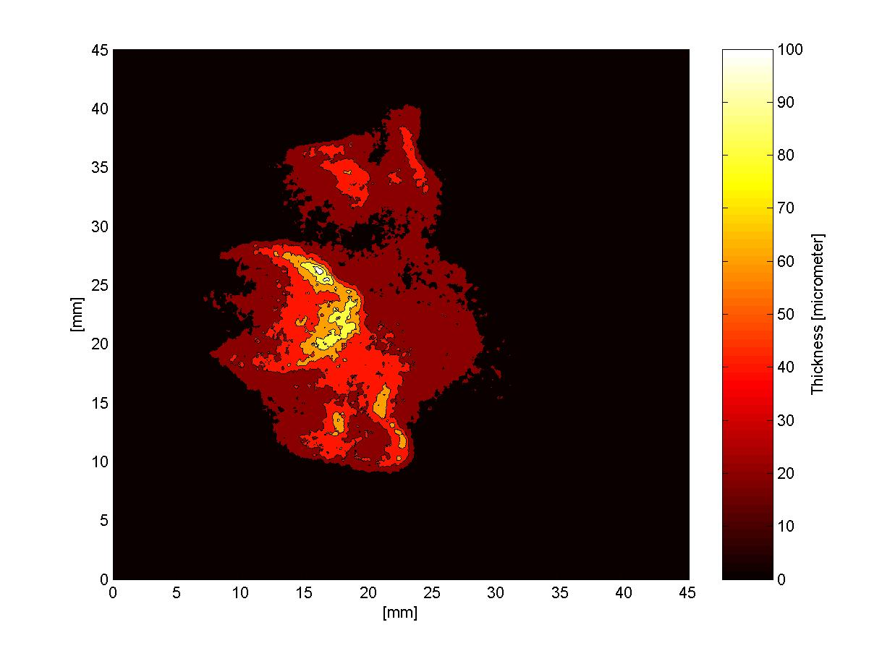
(di) | (dii) | (diii)
 | 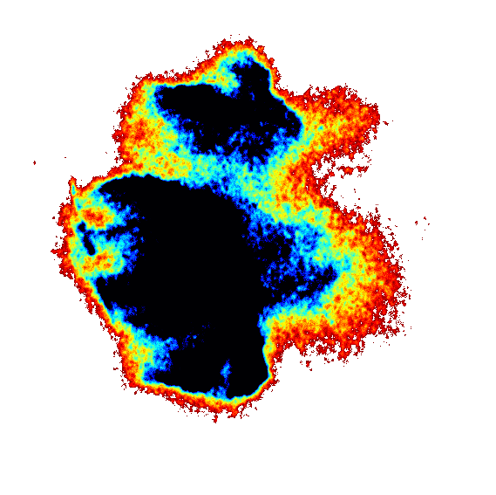 | 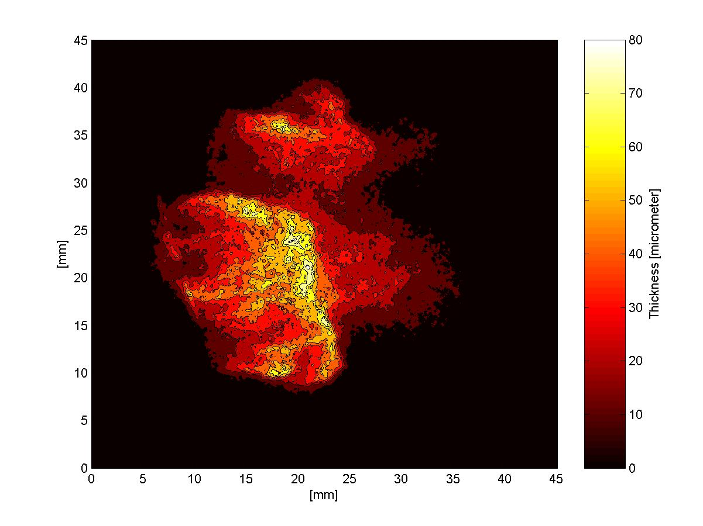
(ei) | (eii) | (eiii)
Figure 5: Transient fuel thickness measurements for different timebins: (a) 1.50 ms ASOI, (b) 1.75 ms ASOI, (c) 2.00 ms ASOI, (d) 2.25 ms ASOI; (e) 2.50 ms ASOI.

Figure 4 presents the side view and footprint image recorded for different timebins. Figure 4ai shows clearly the presence of airborne fuel above the quartz piston. However, no fluorescence signal is recorded in Figure 4aii implying that the fuel has not impacted the piston. By contrast, Figure 4bii shows the first evidence of impinging fuel 1.25ms after start of injection (ASOI). The sac volume can be clearly identified and bottom half of the hollow cone characteristic from these spray structures. The corresponding side view (Figure 4bi) corroborates the impact of fuel as the film can be seen at the bottom of the image. This figure confirms that fuel is excited only after contacting the piston surface and not from pre-impingement airborne droplets.

Figure 5 shows the development of the fuel film for subsequent timebins. At 1.5ms ASOI Figure 5aii illustrates an apparently symmetric fuel distribution where the sac volume can be identified isolated on the right side and the hollow cone has a semi-circular shape around it. The thickness recorded for this image is presented in Figure 5aiii, with average thickness of approximately 20 microns and some peaks at 40 microns. The following timebin (Figure 5bii) shows increased fuel deposits and asymmetric fuel distribution with a tendency for the liquid film to move anticlockwise. This behaviour can be explained as the swirl component of velocity for this injector is positive anticlockwise as seen from underneath. The average thickness for this timebin is close to 40 microns.

At 2.00 ms ASOI, Figure 5ci illustrates the end of injection event. At this timebin the injector has already closed and the total mass has been injected, although there is still airborne fuel. The area of the footprint image increases for this instance as can be seen in Figure 5cii. There is indication of airborne fuel even for the next timebin (Figure 5di), while the average thickness measured seems to be still around 40 microns. In Figure 5eii the liquid fuel film area has reached its maximum size. The thickness distribution presented for this timebin (Figure 5eiii) shows that most of the fuel is located in the bottom half of the image.

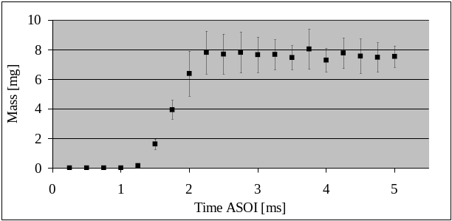
Figure 6: Total mass impingement recorded.

A time resolved total impingement mass quantification is presented in Figure 6 produced by integrating the fuel film thickness over the spatial domain for each timebin. The average mass impinged presented is the result of the average of ten injections for each timebin. The graph shows around a total of 7.75 mg of fuel deposited on the piston surface, representing approximately 70 % of the total mass injected. Since the experiments were performed at ambient conditions, the temperature of the fuel, piston crown, and atmosphere was ambient, which could explain such large deposit measured.

A computational study was conducted alongside the experimental study. The data described in this paper was modelled on a computational fluid dynamics package specifically designed for use in the automotive sector (Ricardo VECTIS) and encouragingly the results from the simulation showed total mass deposition between 7 and 7.5 mg 3 ms after start of injection, similar to that measured (Figure 6). The detail of the simulation, including 3D spatial and temporal predictions, will be discussed in a subsequent paper, and briefly discussed in the presentation.
Conclusion
This paper discussed a new transient 2D LIF technique for quantifying fuel film thickness. Preliminary results showed that the technique was successful in quantifying the fuel film formed as the result of a G-DI injector impingement on a solid surface. The main conclusions are:
- The transient fuel film from an impinging spray was successfully quantified.
- Errors from illuminating airborne droplets were corrected by utilising the total internal reflection of the exciting laser beam.
- 70 % of the total mass injected impinged on the piston surface under atmospheric ambient conditions and room surface temperature.
- Preliminary CFD results predicted around 62-67% of impingement deposits.

Future work will attempt to perform impingement tests at elevated conditions, and also compare results obtained by this method with CFD impingement simulations with Ricardo VECTIS.
References
[1] Li, J., Matthews R.D., Stanglmaier, R.H., Rberts, C.E., Anderson, R.W.: “Further experiments on the effects of in-cylinder wall wetting on HC emission from direct injection gasoline engines”. SAE publications, 1990-01-3661, pp 75-86

[2] Stanglmaier, R. H., Li, J., Matthews, R.D.: “The effect of in-cylinder wall wetting location on the HC emissions from SI engines”. SAE publications, 1999-01-0502

[3] Kay, P.J., Bowen, P.J., Gold, M., Sapsford, S.: “Impingement studies of G-DI Sprays at Atmospheric and Elevated Ambient Densities”, 2005. Annual conference on Liquid Atomisation and Spray Systems, North and South America Irvine, California

[4] Kay, P.J., Bowen, P.J., Gold, M., Sapsford, S.: “Development of a 2D quantitative LIF technique towards Measurement of Transient Liquid Fuel Films”, 10th International Congress on Liquid Atomisation and Spray Systems Kyoto, Japan, 2006.

[5] Schulz, C., Sick, V.: “Tracer-LIF diagnostics: quantitative measurement of fuel concentration, temperature and fuel/air ratio in practical combustion systems”, Progress in Energy and Combustion Systems, 31, 2005, 75 – 121.

[6] Koban, W., Koch, J.D., Sick, V., Wermuth, N., Hanson, R.K., Schulz C.: “Predicting LIF signal strength for toluene and 3-pentanone under engine-related temperature and pressure conditions”, Proceedings of the Combustion Institute, 30, 2005, 1545–1553.

[7] Kull, E., Wiltafsky, G.: “Two Dimensional visualization of liquid Layers on transparent walls”, Opt. Lett. 22, 1997, 645

[8] Hoon, C: “Measurement of liquid fuel film distribution on the cylinder liner of a spark ignition engine using the laser-induced fluorescence technique”, Meas.Sci.Technol, 14, 2003, 975-982)

[9] Zhao H., Ladommatos N.: “Optical diagnostics for In-Cylinder mixture formation measurements in IC engines”, Prog. Energy Combust. Sci., Vol 24, pp 297-336, 1998

